24. Design DFA using simulator to accept the string having ‘ab’ as substring over the set {a,b}

AIM: To design DFA using simulator to accept the string having ‘ab’ as substring over the set {a,b}

TRANSITION DIAGRAM:

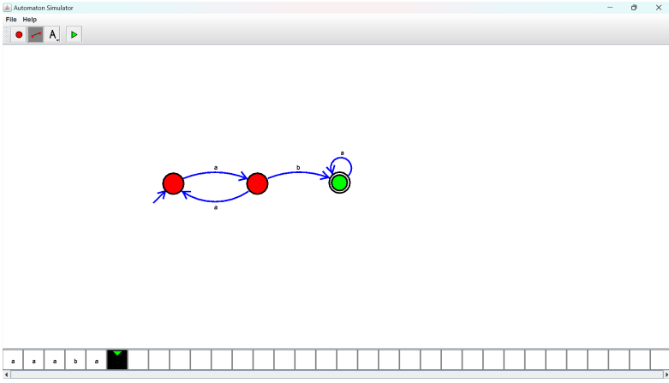

**RESULT**: Hence designing DFA using a simulator to accept the string having ‘ab’ as substring.